**Tutorial on processing of single crystal diffraction data at high pressure using ATREX IDL and RSV**

By Przemyslaw Dera,

*Hawaii Institute of Geophysics and Planetology (pdera@hawaii.edu)*

**June 21, 2015**

*Development of this software is supported by NSF GeoInformatics award EAR 1440005*

Table of Contents

Initial setup 2

Detector calibration 3

Goniometer settings 8

Peak search 12

Peak indexing and determination of orientation (UB) matrix 14

Peak prediction 16

Peak fitting 18

Peak prediction and fitting for image series 21

Merging of peaks from different detector positions 23

Scaling and rotation-dependent intensity corrections in ATREX 27

Exporting SHELX hkl file with structure factor amplitudes 29

# Initial setup

Start the program by double clicking on the GSE_ADA icon (assuming that IDL VM has been installed correctly).

The demo data set was collected with a MAR165 CCD detector, and the diffraction images were saved as tiff files. Select the correct (default) image format:

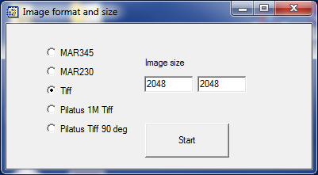

On my computer, after downloading from GitHub, the demo data is located in the following directory:

C:\Users\przemyslaw\Documents\GitHub\GSE_ADA\Demo_data

Select output directory. For the purpose of this demo we will create “analysis” folder in the diffraction image directory:

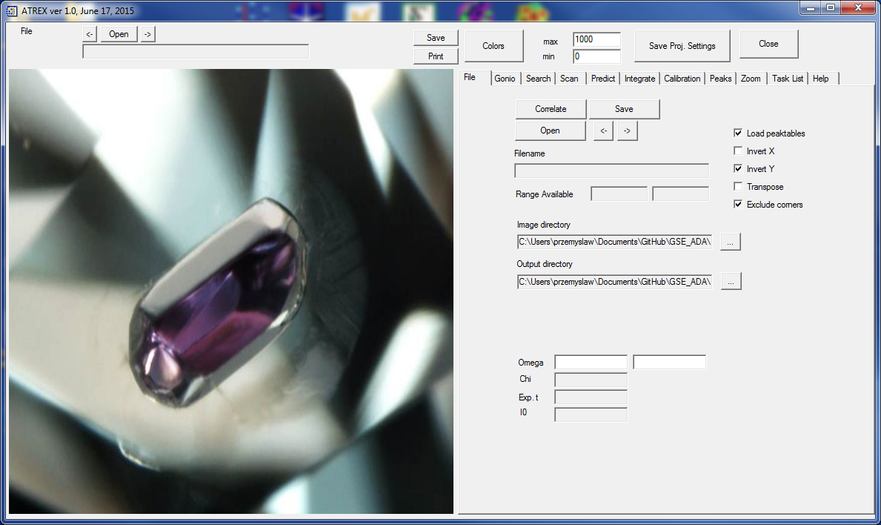

# Detector calibration

Open one of the calibration images. For this experiment calibration data was recorded for LaB6 powder sample. For this detector the pixel size is 0.079mm. The wavelength for the experiment was 0.3344A, and the detector was placed at an approximate distance of 200mm.

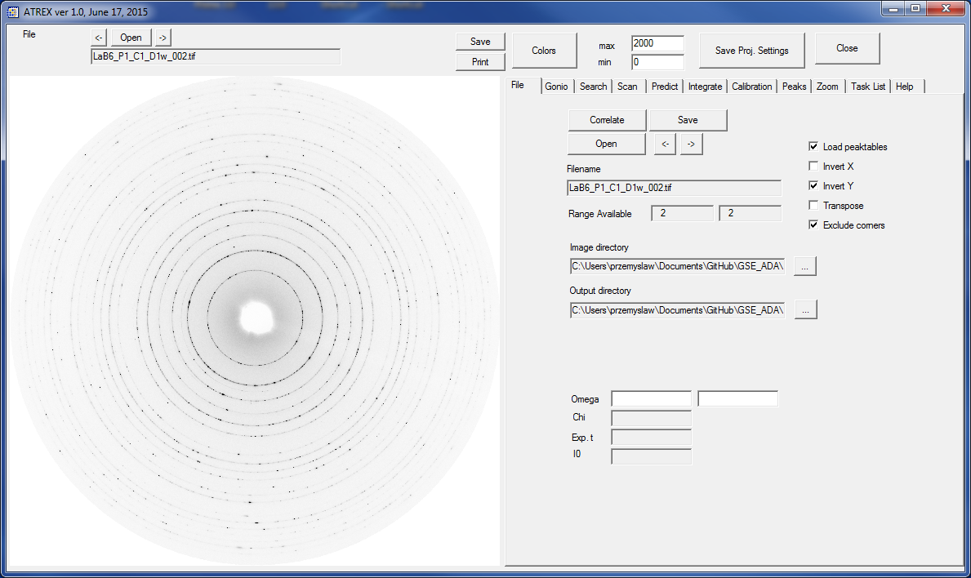

The diffraction data for the sample was collected at three detector positions. The first position (file names containing D1) has the incident beam hitting the detector close to the geometric center of the image. The remaining two positions differed from D1 by translation of the detector in horizontal plane, approximately perpendicular to the incident beam, by abut 70mm to the right (file names containing D2) and to the left (file names containing D1).

You have to calibrate the detector geometry at each of these three detector positions first, in order to be able to analyze the single crystal data. After you open a diffraction image, the program checks if there is a calibration .cal file associate with it. If you are opening the image for the first time, there is no calibration yet, so the program will display a dialog asking you to select one and save it in the image directory. You can do this after you complete the calibration.

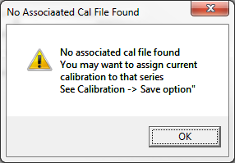

Go to the “Calibration” tab. Set the correct starting values of the detector parameter (pixel size, wavelength, approximate distance). The “Test” button allows you to adjust and test the signal to noise ratio for automated selection of points along the Debye-Scherrer rings. The program requires at least 8 points along a ring, for the ring to be used in the refinement. The image below was obtained with s/n ratio of 2.0 (this means that points with intensity 2x higher than local background will be used). Pixels that satisfy the signal to noise are marked with purple, whereas pixels that belong to acceptable rings are marked with blue.

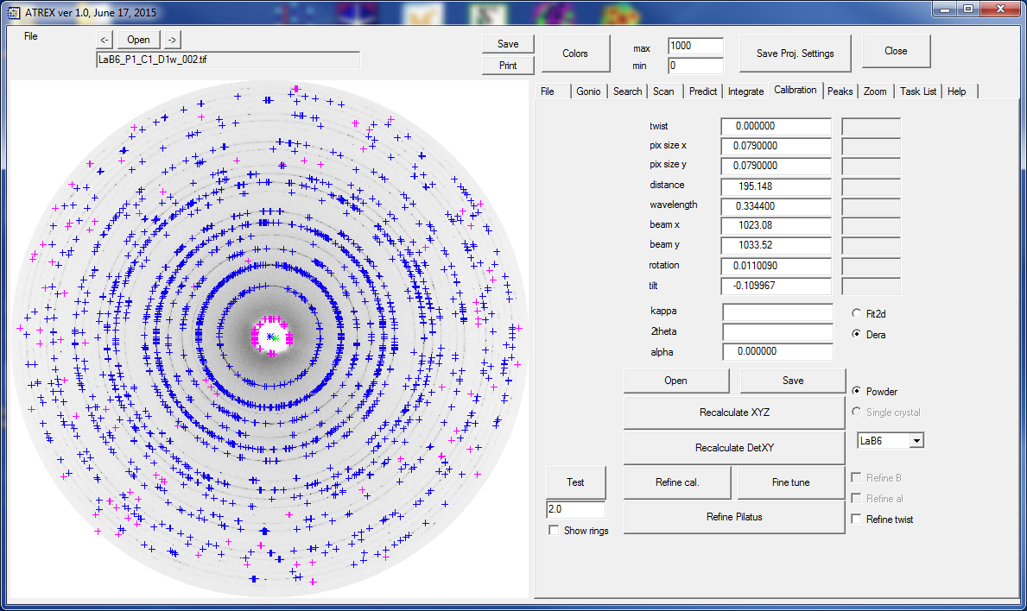

This should be sufficient, but if you want to use more points, adjust the number below the “Test” button to 1.0, and click “Test again”. There are more points selected for refinement now, as shown below.

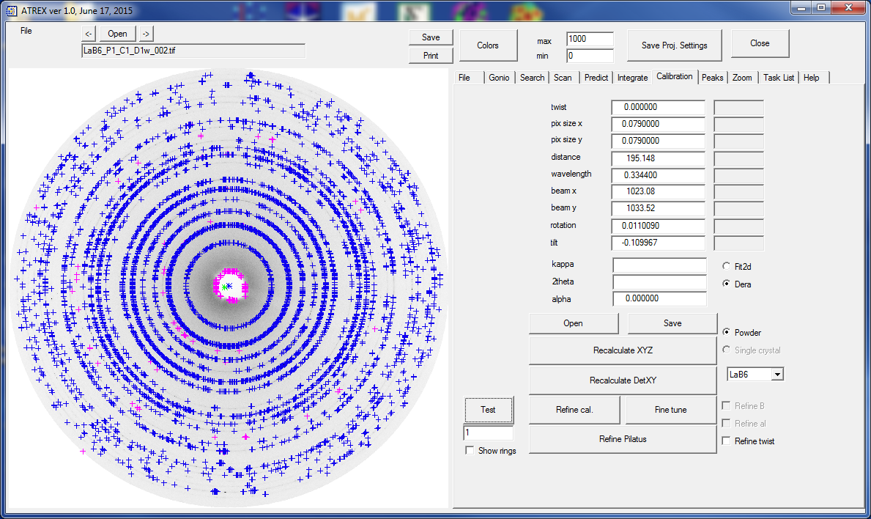

Click the “Refine cal” button. The program goes through the calibration calculations and will display the dialog below, when it is finished.

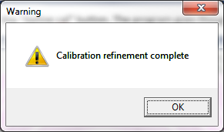

After the calibration refinement is completed, the program displays standard deviations of all refined parameters in grey boxes next to the parameter values. ATREX can use one of two definitions of the calibration parameters. One of them is consistent with fit2d, the second uses an alternative definition of the “rotation” parameter. The definition of the parameter can be switched with radio buttons. **Make sure that you calibrate and use for further calculations consistently the same type of calibration parameters.**

To check if the calibration worked well you can overlay the calculated Debye-Scherrer rings onto the diffraction image of the calibrant using the “show rings” check box. The available calibrants include CeO2 and LaB6.

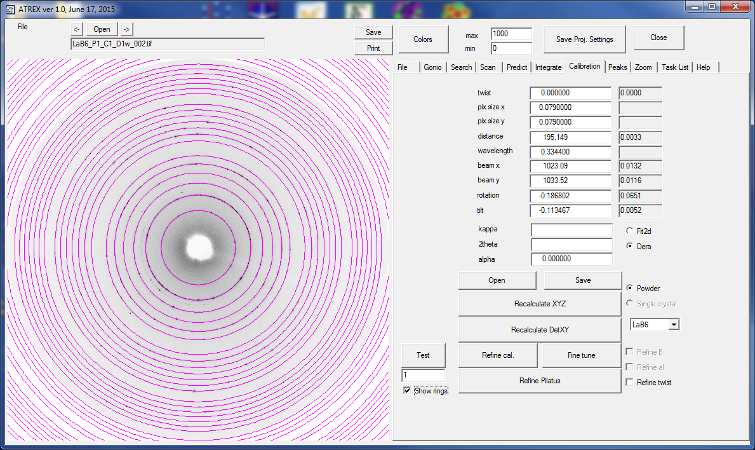

Save the calibration by pressing the “Save” button in “Calibration”.

Repeat the calibration procedure for the D2 and D3 detector positions. The wavelength, pixel size and approximate distance are the same for all three detector positons. Results of the calibration for the D2 detector postion are shown in the figures below.

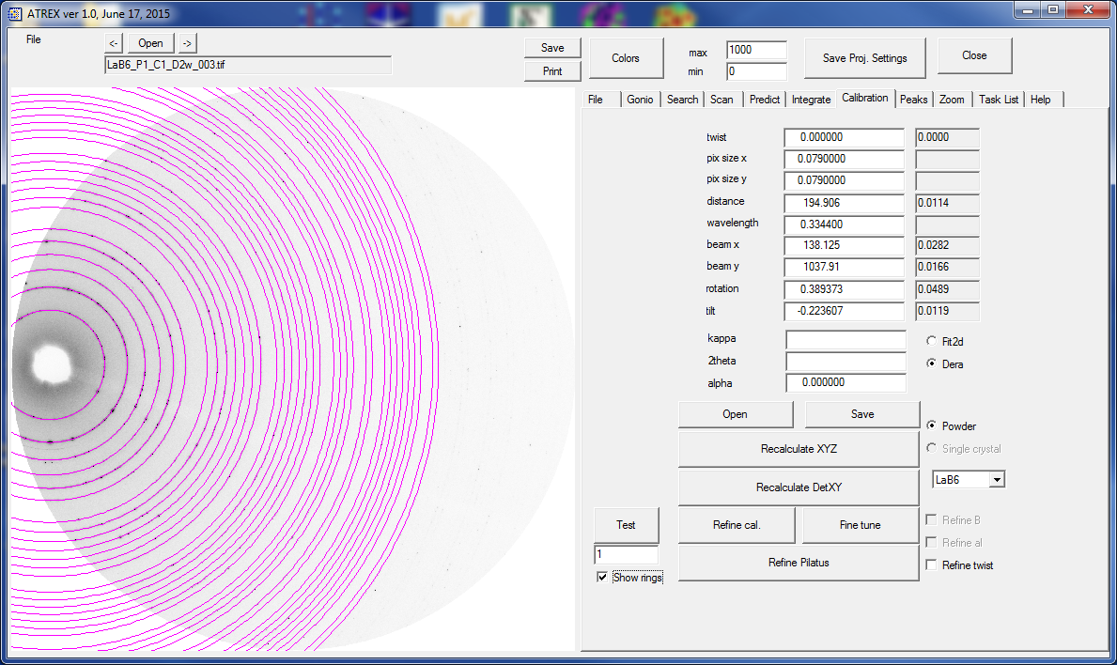

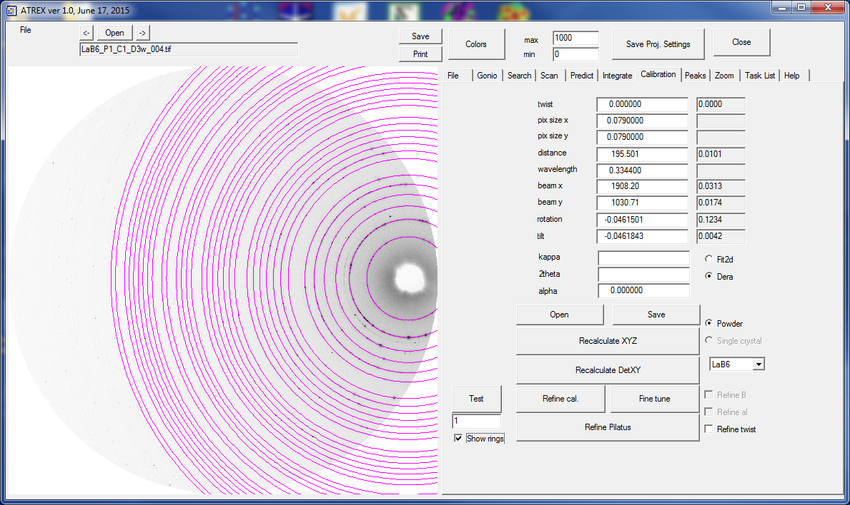

# Goniometer settings

It is time to look at the diffraction images of the sample now. Before you do that, tell the program about the setting of the goniometer you used. Different instruments use different definition of positive rotation direction, and different offsets. At the APS synchrotron beamlines 13IDD and 13BMD have the rotation direction consistent with ATREX, but use an offset of -90 deg. 16IDB and 166BMD use inverted rotation and 0 offset. 13BMC has inverted rotation and -90 deg or 90 deg offset. Input the correct settings under the “Gonio” tab before proceeding further with the analysis.

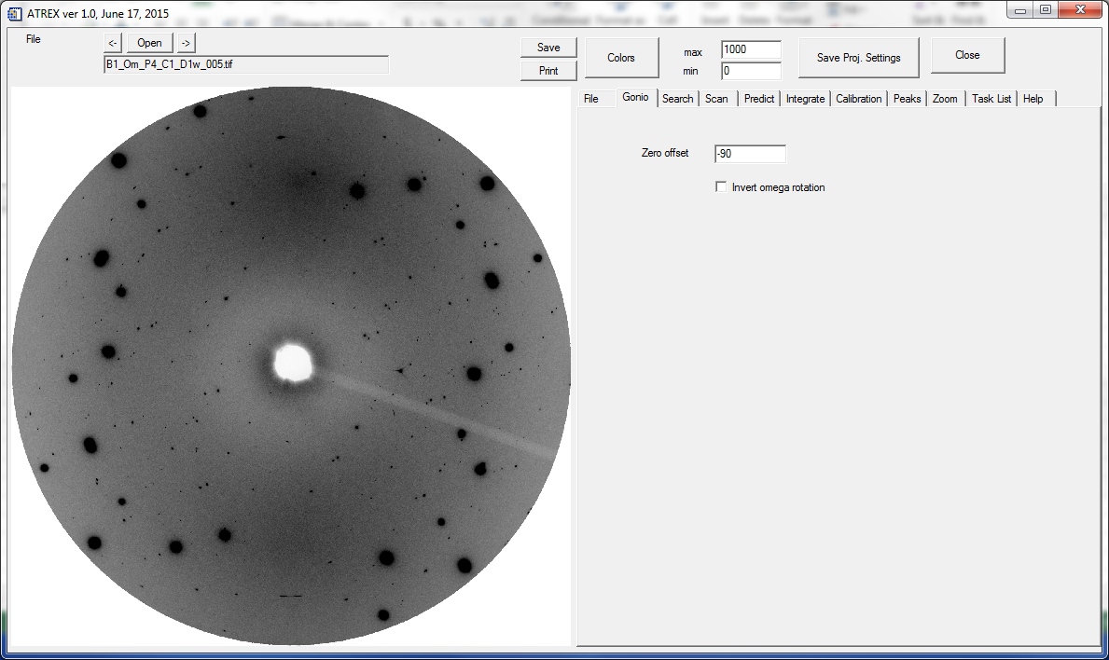

ATREX allows to adjust the contrast of the image display by selecting two parameters, minI and maxI. In the default inverted greyscale color scheme all intensities above maxI are displayed as black and all intensities below minI are white, whereas everything in between is an appropriate shade of gray.

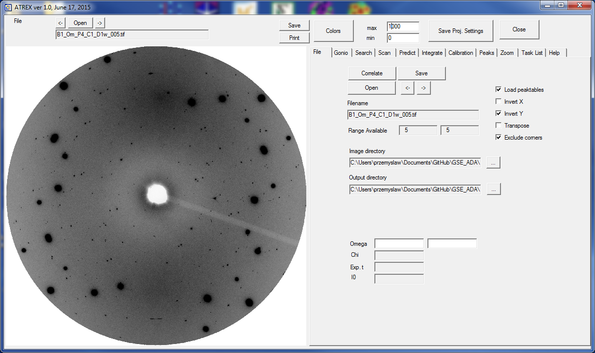

The image above is a little dark. Adjust maxI from 1000 to 2000 for better visibility. The result is shown below.

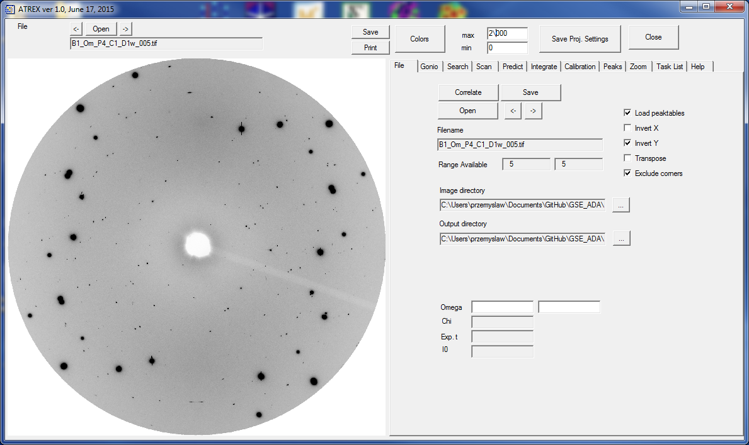

Each image series (series of image files where the names contain consecutive 3 digit sequence numbers) shares the same detector calibration. To assign calibration to an image series make sure that the correct calibration is loaded and simply save it (using “Save” button in the “Calibration” tab) with default name proposed by the program (it will be saved in the image directory). If you open any image belonging to the same series again, ATREX will know which calibration to use. You will have to do it separately for each individual image series.

During the demo experiment, we used a diamond anvil cell equipped with Boehler/Almax diamonds, with 66 deg. total opening angle. The pressure was 7.8 GPa, and the pressure transmitting medium was He. We collected data in a series of 1 deg. steps at detector position D1 (filenames B1_Om_P4_C1_D1s_006.tif to B1_Om_P4_C1_D1s_071.tif), one wide rotation image, covering the whole 66 deg. at detector position D1 (B1_Om_P4_C1_D1w_005.tif), and two sets of four 16.5 deg. wide steps for detector positions D2 (B1_Om_P4_C1_D2s_140.tif to B1_Om_P4_C1_D2s_143.tif) and D3 (B1_Om_P4_C1_D3s_150.tif to B1_Om_P4_C1_D3s_153.tif). The sample in this experiment was a natural crystal of omphacite pyroxene from the RRUFF collection:

<http://rruff.info/omphacite/display=default/R061129>

Start by assigning appropriate detector calibrations to each of the series (it is enough to assign calibration to just one image belonging to the series).

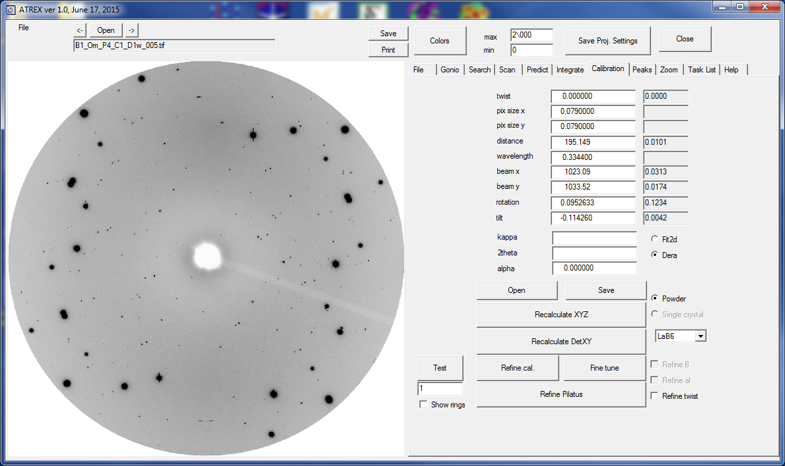

During the data collection, with each diffraction image the data collection program saves an ASCII file with image setting, that contain the start rotation angle, rotation range, exposure time, etc. You can see in the “Scan” tab that ATREX reads these files and enters for you the appropriate information. This information is also automatically passed to the “Predict” tab, where the setting for calculating peak positions from the orientation matrix are defined.

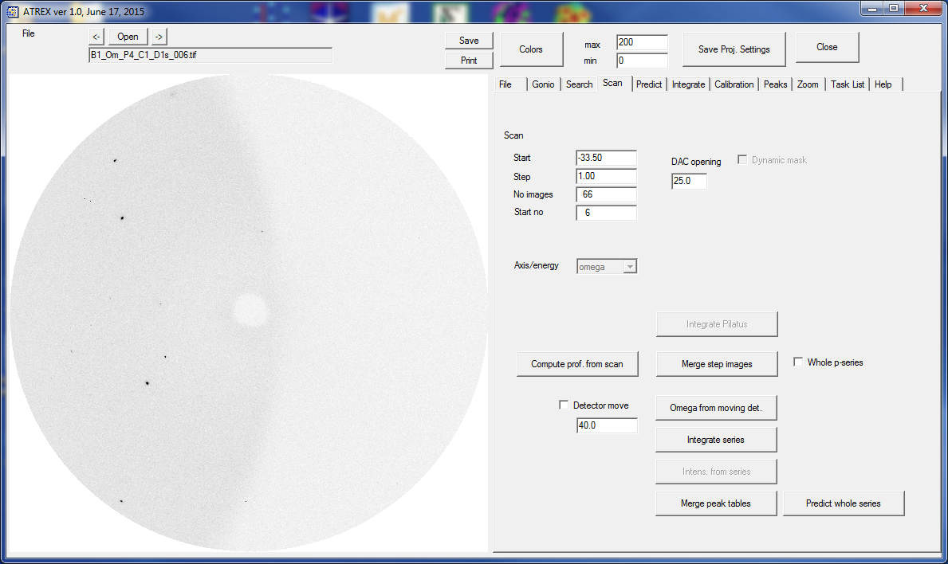

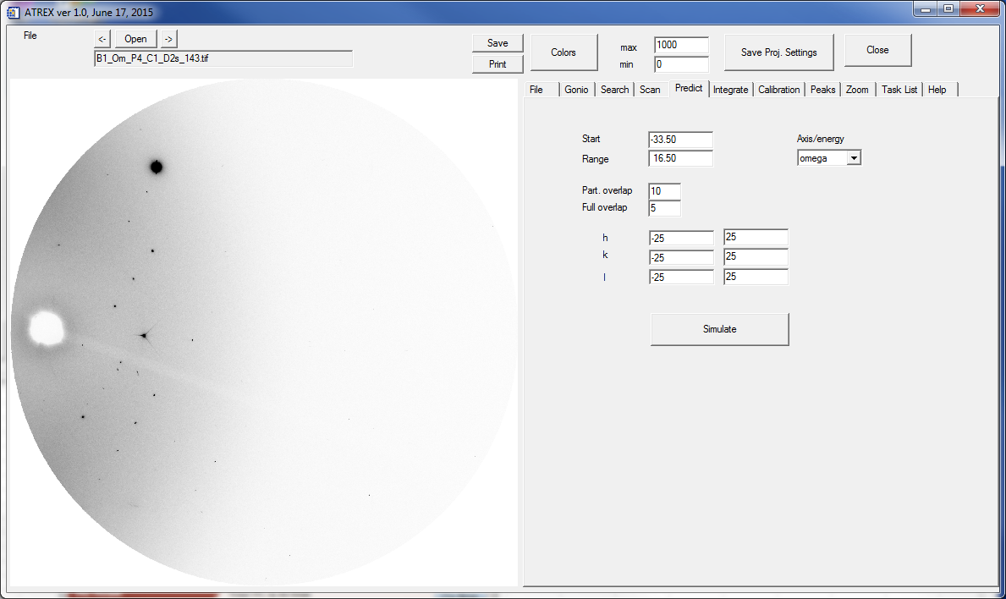

If your data does not have setting files, ATREX will allow you to generate them for each image series, if you specify the appropriate information yourself.

# Peak search

Open one of the step images for detector position D1. In “Search” tab select the “fit peaks” button. Click the “PS Series” button. The program will go through all of the images belonging to the step scan series and perform peak search and fitting in individual images. A peak table .pks file will be saved for each individual image of the series. At the end of this process ATREX will merge all of the peaktables into one and also save the resulting peaktable. You can also run peak search without peak fitting. It will be much faster, but the resulting peak positions will be a little less accurate, leading to poorer quality of orientation matrix.

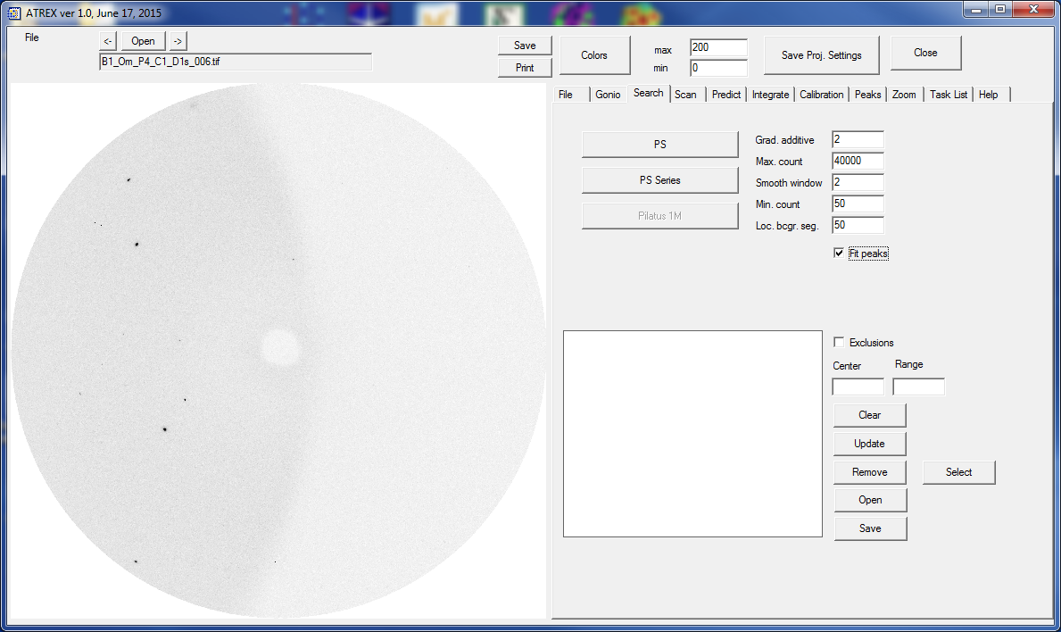

At the end of peak search the image should looks similar to the one in the figure below. Peaks marked with green color are the ones for which ATREX could not do a satisfactory peak fit. Start by removing these peaks by clicking the “Delete” button in “Peaks”.

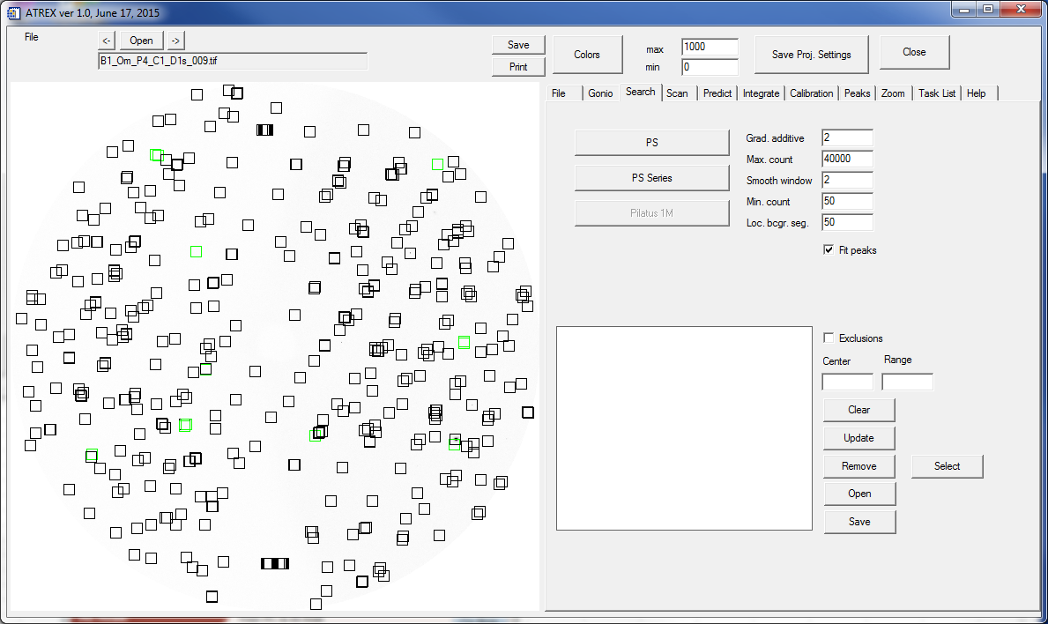

The resulting merged peaktable is automatically should be saved in a file “B1_Om_P4_C1_D1s__merge.pks”

# Peak indexing and determination of orientation (UB) matrix

You can do the peak indexing and orientation matrix determination in RSV, like in the previous version of this IDL software, GSE_ADA/RSV, but ATREX now also has an interface which allows to launch cell_now directly. To do that go to “Predict” and click the “Simulate” button. Indexing is available by clicking the “Index” button in the “Diffraction image simulation” window.

You will have to tell ATREX what is the location of the cell_now.exe executable on your computer (cell_now can be obtained from Bruker AXS or from prof. George Sheldrick). Use the “Browse” button in the window below to select the file location, and then click “OK”.

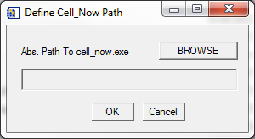

ATREX launches cell_now in the background and takes care of the internal dialogs. The results (choices of the unit cells) are captured and displayed in a new window, shown below.

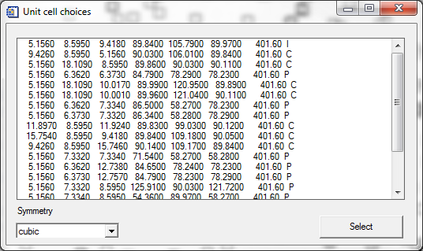

The demo sample, omphacite has a monoclinic unit cell with approximate unit cell parameters a=9.5A, b=8.6A, c=5.1A and beta=106 deg. Select solution number 2 from the list, which shows the correct unit cell. When you make the selection, ATREX recognizes the most likely symmetry (monoclinic with b-unique in our case), but you can override the automated selection. Click the “Select” button. The program performs a simple refinement of the orientation matrix and selects (marked with green color) peaks that do not conform to the orientation matrix. The results are shown in the figure below. There are quite a lot of peaks that were not indexed correctly, but it is ok. We run the peak search with high sensitivity so in addition to the sample peaks, there are diamond peaks and a few dark current noise peaks as well.

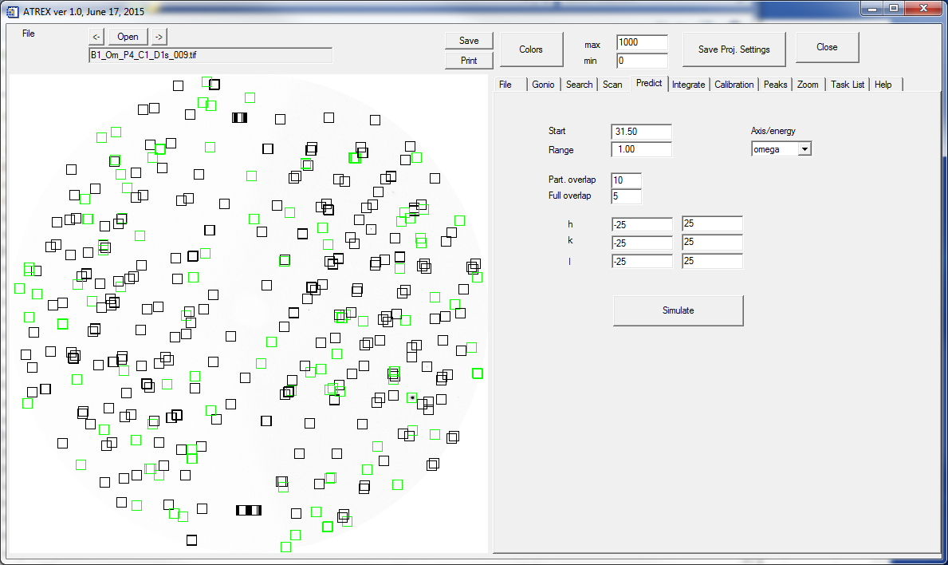

The orientation matrix and lattice type you selected were passed to the “Simulation” window. Natural omphacite comes in two polymorphic varieties C2/c (cation disordered, obtained by fast quench from high temperature) and P2/n (cation disordered, obtained by fast quench from high temperature). Even though cell now suggested C-lattice type, our demo sample is the P2/n variety. The peaks that violate the C-type systematic absences are few and weak, but clearly there. Before proceeding further make sure that the “Bravais lattice type” in the simulation window is set to “P”.

ATREX remembers associations of UB matrix with individual file series. Now you have a non-zero UB matrix and the program asks if you want it to remember this association through the dialog below. If you confirm, a new .ub file will be saved in the image directory. The name of this file is “B1_Om_P4_C1_D1s_.ub”

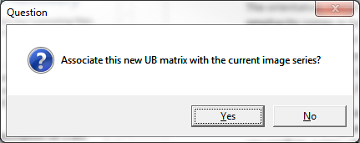

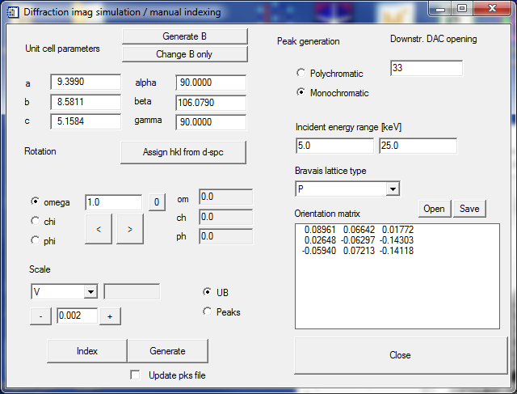

# Peak prediction

Open the wide rotation image for detector position D1. It has all of the sample peaks accumulated, and you can use it to verify if your orientation matrix is satisfactory. There is a non-zero UB matrix in the memory, but the program does not find a UB file in the image directory associated with this image file, so it asks you if you want to associate the current UB with the file series.

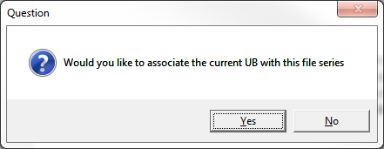

If you confirm, a new “B1_Om_P4_C1_D1w_.ub” file will be written.

Change the “Downstr. DAC opening” to 33 deg., which was the case for this demo experiment. Delete all the peaks (“Clear” button in “Peaks” tab), and click “Generate” in the simulation window. The result should look like in the figure below.

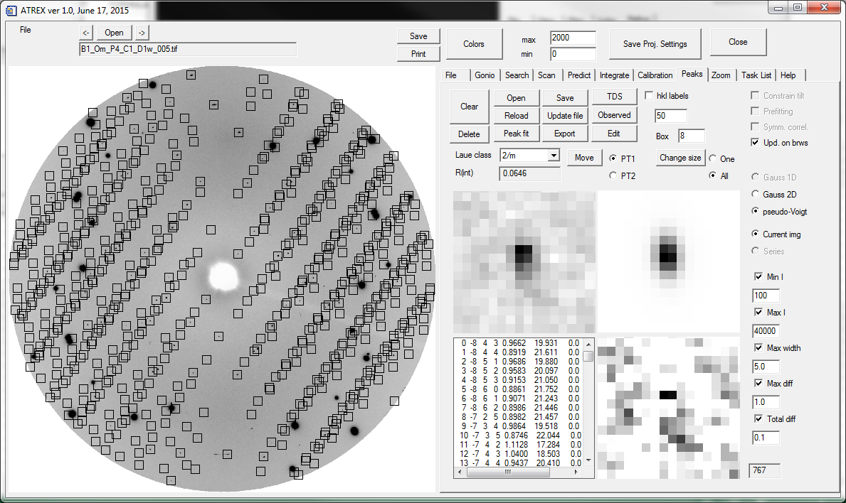

All sample peaks are correctly predicted using the orientation matrix we have. In some cases with large unit cells some predicted peaks are so close together in the image that reliable fitting is not possible. ATREX will identify such cases and select the offending peaks (with green) for you. If any peaks are marked with green, after executing the “generate function”, remove them before proceeding further (for this demo dataset there should not be any too-close special overlaps).

We will use the wide rotation image at D1 instead of the small 1 deg. steps for determination of peak intensities, because the signal to noise is high, there are no problems with spatial overlaps, and the wide image is free from the synchronization errors that step images collected quickly sometimes suffer.

The next step is to filter out unobserved peaks. This is done in the “Peaks” tab by clicking the “Observed” button. The number to the right of the button determines the minimum intensity count above background within 5x5 pixel region around the predicted peak position that has to be satisfied for the peak to be recognized as observed. This data was collected with good statistics, so let’s use a 50 count threshold. The result of filtering of unobserved peaks is shown below. Remove the selected peaks (“Delete” button in “Peaks”).

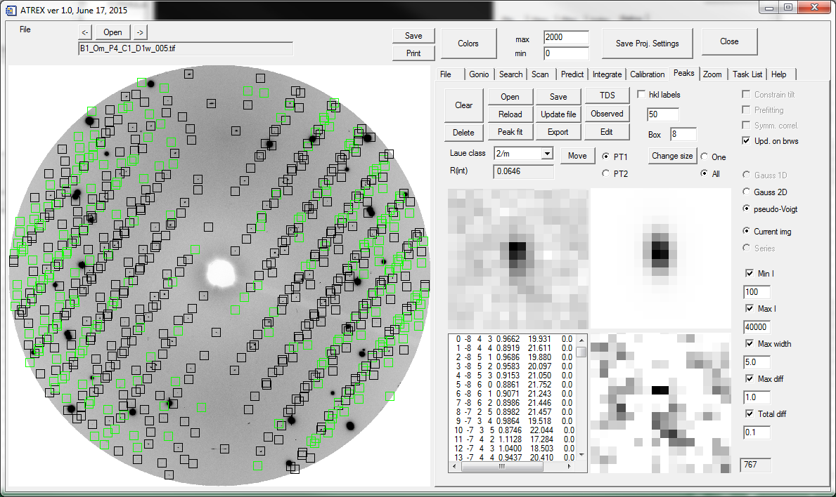

# Peak fitting

The next step is peak fitting. Make sure that the fitting box size (number to the right of “Box” label in peaks) is appropriate. For the demo data the default box size of 8 (this parameter is a box “radius”, so the real fitting box is 17x17 pixels) is ok, though for other datasets, particularly collected at higher pressures, where peaks are broader you may need to make this number larger. Click on couple of peaks in the peak list, and see if the peak profiles fit well within the fitting box. You can see the result of the fitting in the three graphical windows on the bottom-right side of the “Peaks” tab. They correspond to the zoom of the actual image, fitted profile and the residual intensity (image – fitted profile).

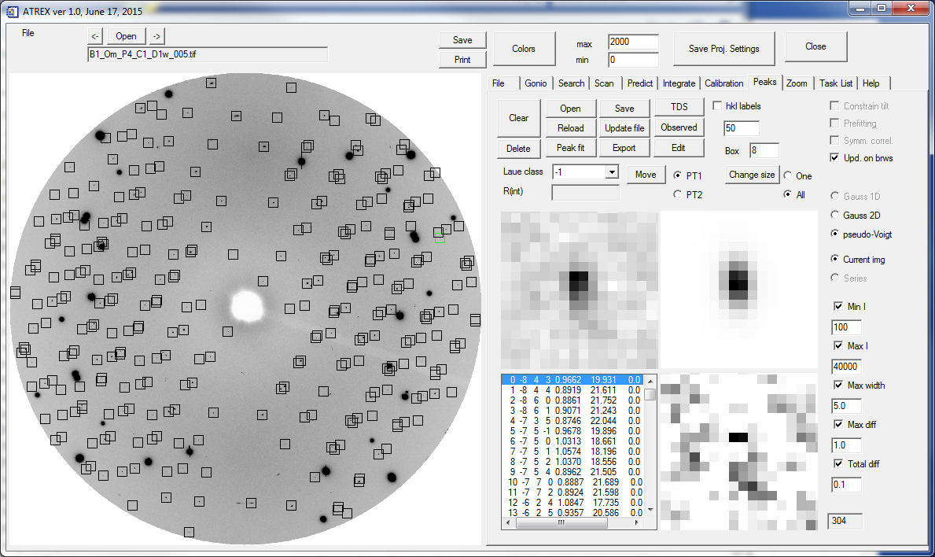

ATREX offers a built-in cBN backing plate absorption correction, but the demo dataset was collected in a DAC without a cBN seat, so we have to disable this correction in “Integrate/Corrections”, like shown below.

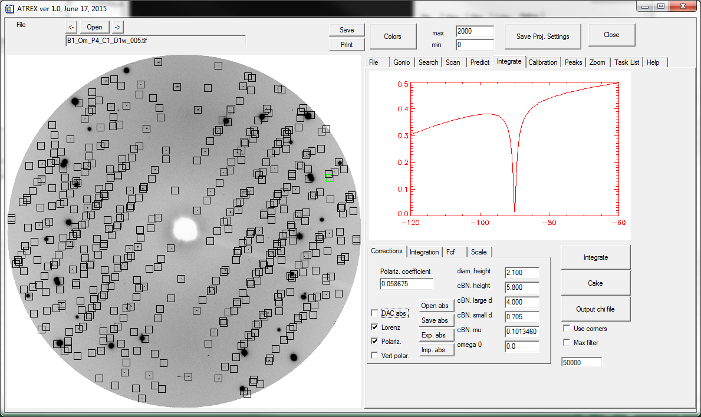

If you are satisfied with the box size, select the correct Laue class for your crystal (2/m for omphacite) and click the “Peak fit” button in “Peaks”. Fitting of the ~470 peaks on my desktop computer takes about 30 seconds. At the end ATREX selects again with green the peaks for which a convincing fitting convergence was not achieved. Remove these peaks (“Delete” button in “Peaks”).

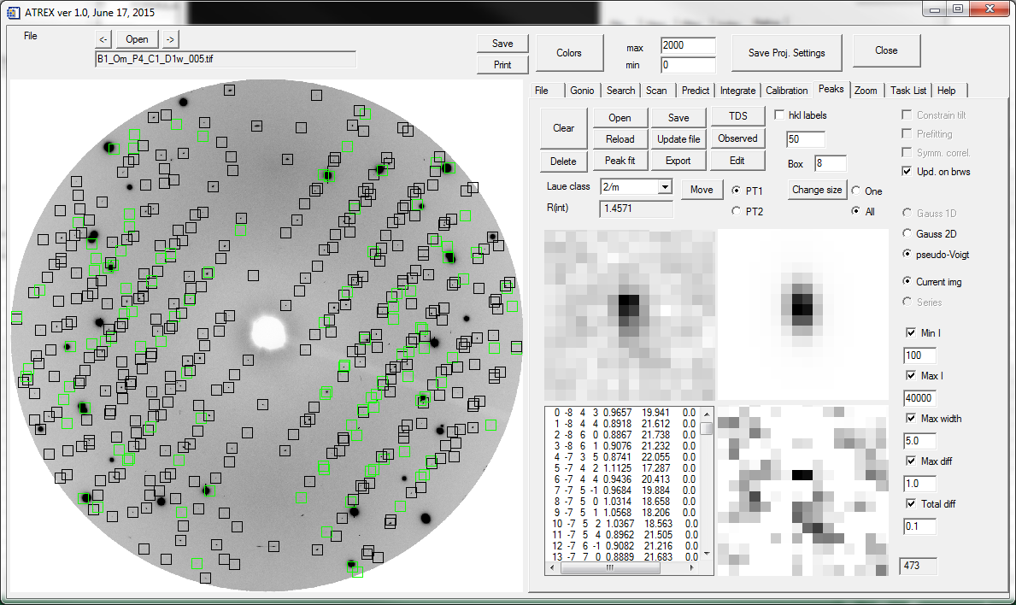

After the fitting and removal of bad peaks the internal consistency factor for all the peaks in this image should be around 9% (before we remove outliers and apply correction for the crystal motion in the beam).

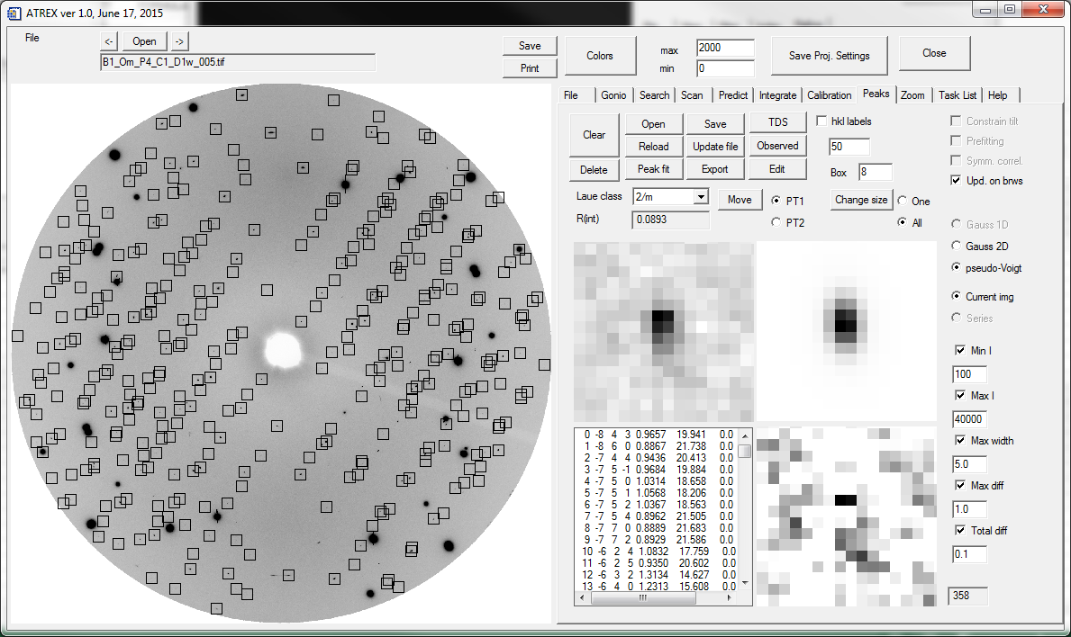

Save the results of the fitting in a .pks file (I just overwrite the B1_Om_P4_C1_D1s__merge.pks file). We have to process the remaining two detector position. Open one of the wide step images at D2. Make sure the correct calibration is saved for this file series.

# Peak prediction and fitting for image series

The orientation of the crystal for this detector position is just the same as for D1. We will use a feature of ATREX which predicts peaks in a file series and processes the whole series automatically. To trigger this function go to “Scan” and click the “Predict whole series” button. ATREX does prediction of peak in each image, filtering of unobserved peaks, peak fitting and removal of bad fits, as well as merges the peaks from all steps at the end. The final result for D2 is shown below. The results are written into a file .pks “B1_Om_P4_C1_D2s__merge.pks”.

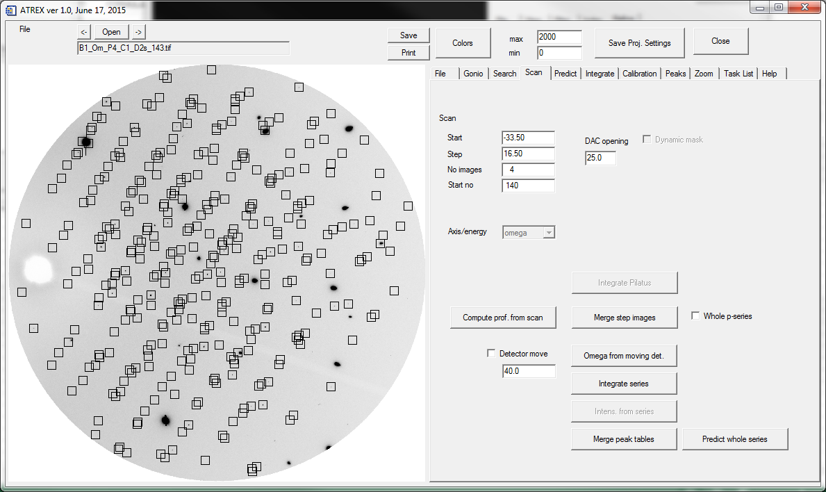

Repeat this operation for the D3 images. The results for D3 are shown below.

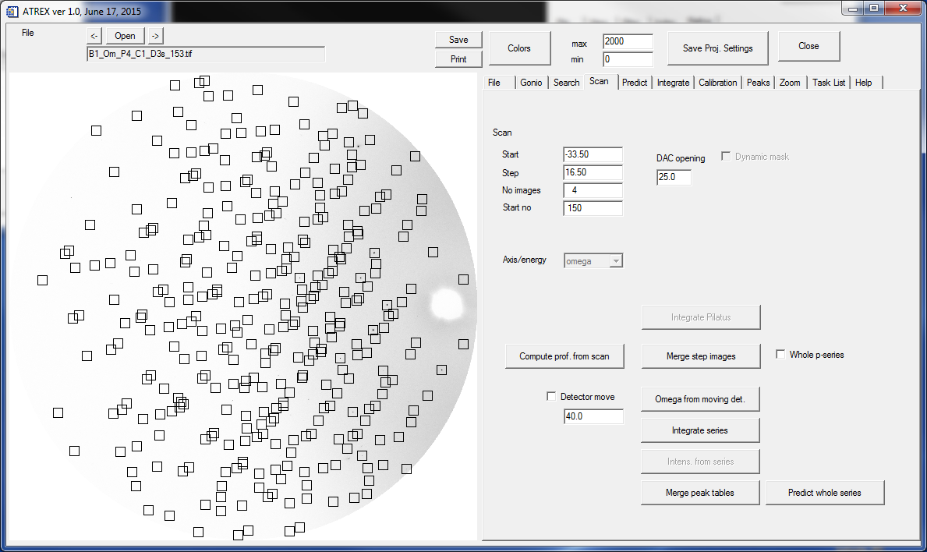

# Merging of peaks from different detector positions

Next step is merging of the peaks from all three detector positions, which is done in RSV.

During the data collection at D1 the sample rotation was two times faster than at D2 and D3 because the offset detector positions contain mainly weaker, high angle peaks. To merge the data correctly you have to open the three .pks file and select appropriate scale factors in RSV. Make sure that the scale factor is set to 1 and open the D1 file. Change scale factor to 0.5 (the speed was slower, so the intensities have to be divided by 2 to bring them to the same level as D1). Select the “append” option. Keep scale factor at 0.5 and open the D3 file. Again, select “Append”.

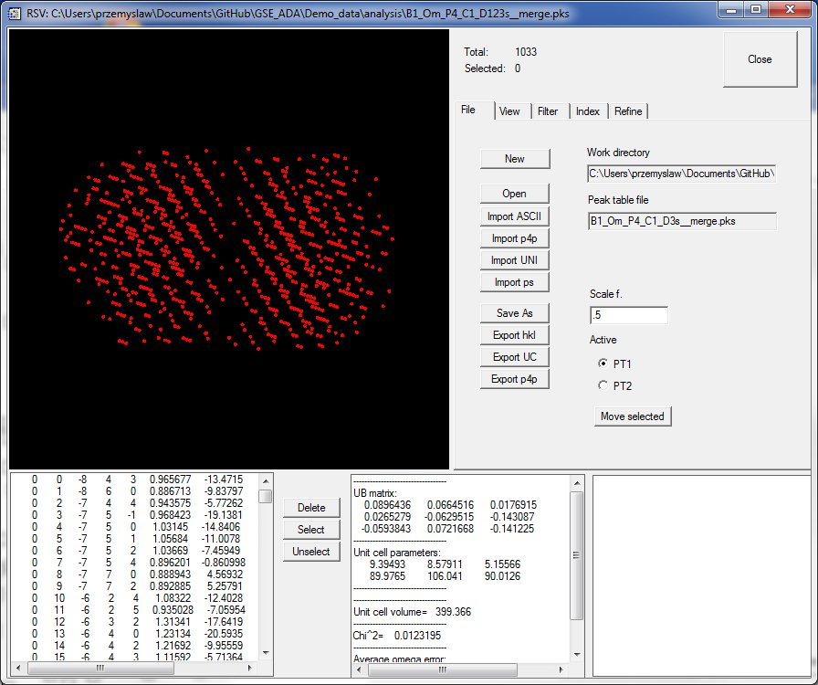

There should be about 1033 peaks in the three combined files. Go to “Index/Index” and click “Recalc. UB”. This will calculate the orientation matrix from the Miller indices and Cartesian coordinates of reciprocal vectors.

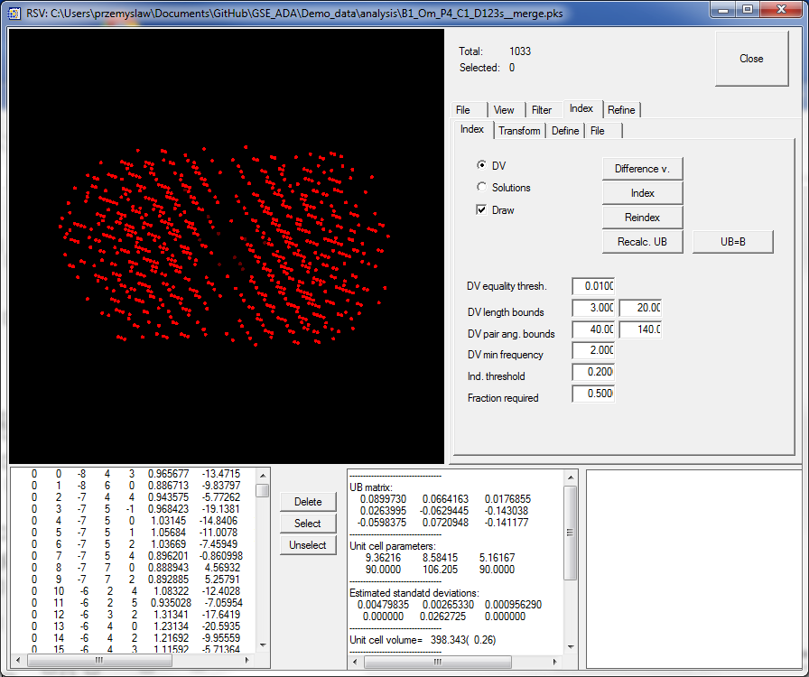

Go to “Refine” and select appropriate symmetry constraint (“monoclinic b-unique” for this crystal). Click on “Refine w/ d-spc” several times. Go to “Filter” and look at the error plot.

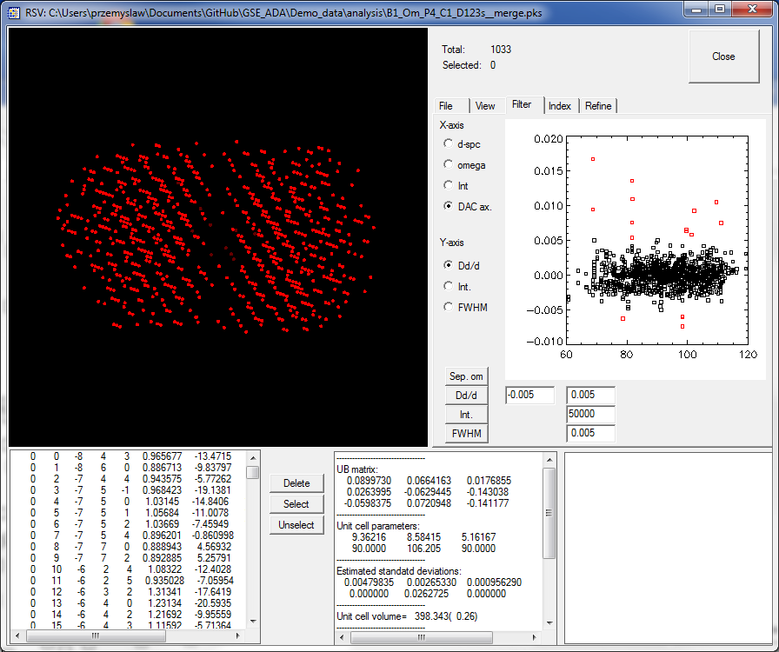

There are few peaks that clearly seem to be outliers. The default limits in d-spacing for recognizing outliers are specified next to Dd/d button. You can change these, if necessary, and click on Dd/d to make a new selection. For the demo dataset the default values should be OK. Delete the outlayer peaks (“Delete selected” in “View”). Look at the error plot again. Outliers have been removed and the distribution of errors seem regular, with no clear functional dependence. Note improvement in unit cell parameter uncertainties after the outlier removal. Write down the unit cell parameters and uncertainties – these will be needed for setting up structure refinement files and for equation of state fitting.

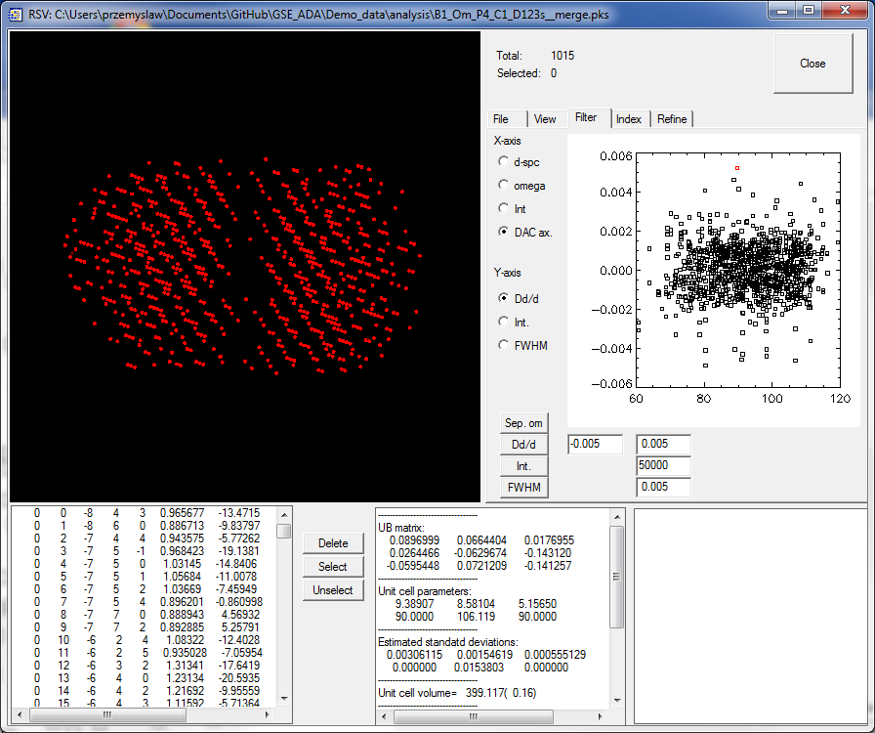

RSV also offers possibilities to filter by peak intensity. Switch the view to displaying omega on X-axis and intensity on Y-axis. It is clear that two peaks are much more intense (by several orders of magnitude) than the rest. It is best to remove these peaks which most likely come from diamond anvils. Set the intensity maximum parameter to 90000 and click on the “Int.” button in ”Filter”. Then remove the selected peaks (“Delete Selected” in “View”).

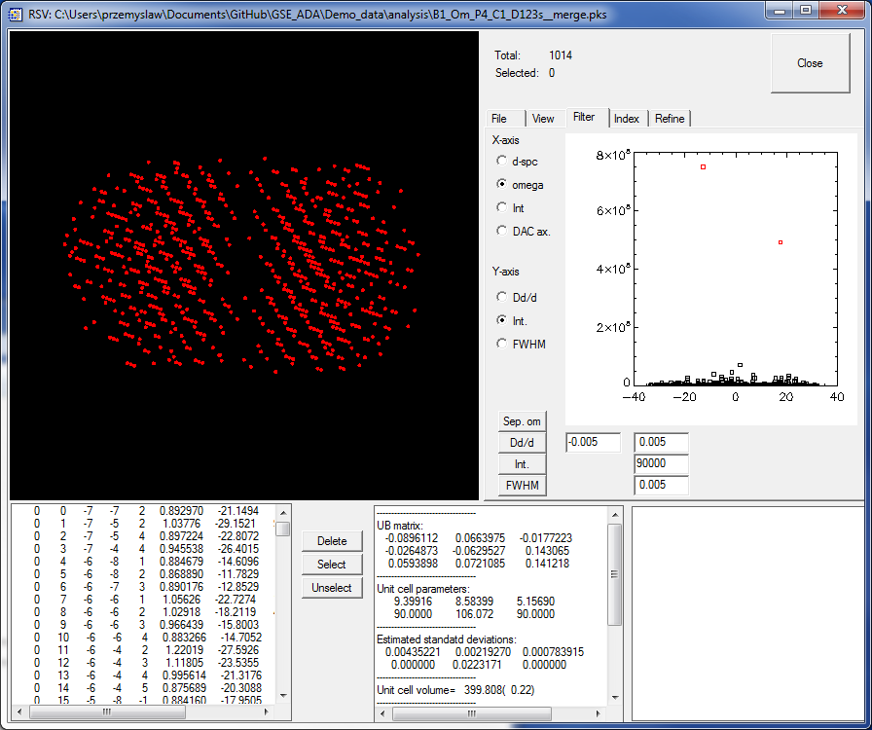

Save the resulting merged peaktable (“Save as” in “File”). You will need to create a new .pks file for this. I called my file “B1_Om_P4_C1_D123s__merge.pks”.

# Scaling and rotation-dependent intensity corrections in ATREX

Open the new file in ATREX (“Open” in the “Peaks” tab). There should be ~1015 peaks showing R_int of 10.65%.

Go to “Integrate/Scale” and click the “scale button”. The plot below shows rotation-angle dependence of individual measurement of peak intensity vs. average intensity for each group of symmetry dependent peaks. There are clearly few outlier. Click the select button, and adjust the selection limits (text boxes below “Select” if necessary). Delete the selected outliers.

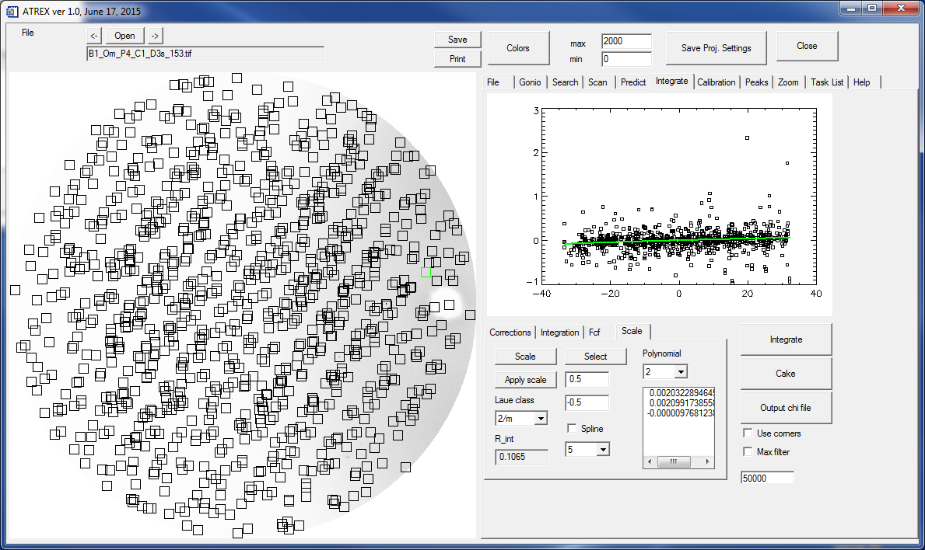

Click “Scale” again. You can see that there is a slight slope of the dependence and the program fits a polynomial curve that accounts for the crystal moving in the beam. Click “Apply scale” and “Scale” again. The slope dependence has been corrected and the R_int dropped to 0.0840, with 972 peaks left.

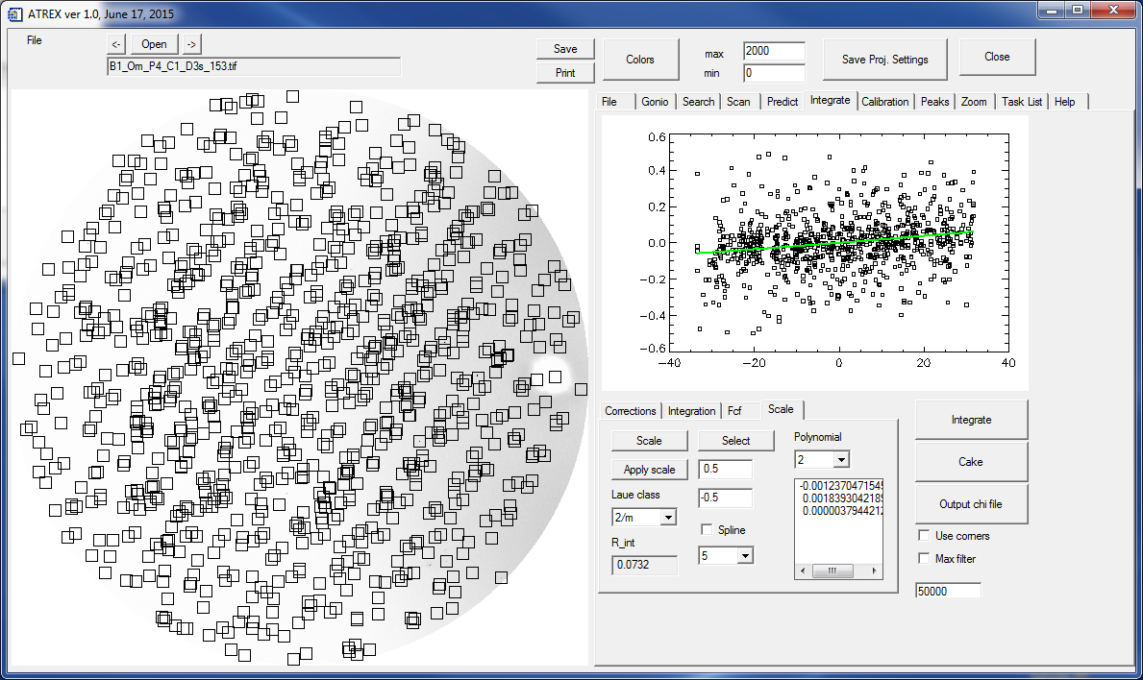

# Exporting SHELX hkl file with structure factor amplitudes

Save the resulting peaktable (e.g. overwrite the previous file). Open the file in RSV. Let’s check if our choice of the lattice type was correct. Go to “Index/Transform” and click “XPREP”. The fist screen in XPREP shows the systematic absence statistics. Each non-primitive lattice type causes a different group of peaks to be systematically absent (have zero intensities). For the C lattice type we have N (total) = 211 peaks that should be absent, but out of these N (int>3sigma) = 210 are observed, so the lattice type is not really C, but P.

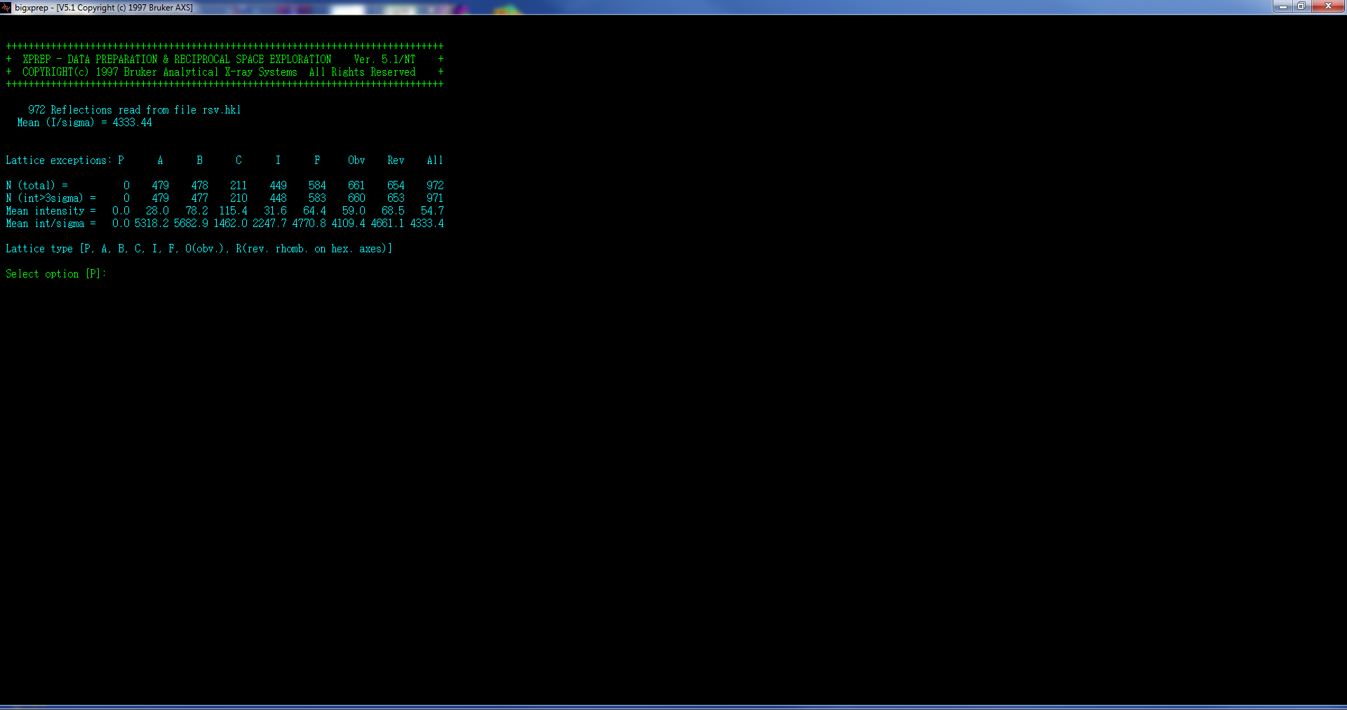

Save .hkl SHELX file using “Export hkl” button in “File”. If you are going to refine the structure using a model that you downloaded from a database, you have to make sure that the setting of the unit cell in RSV is consistent with the setting of your model. For omphacite this should be the case (the “a” unit cell parameter is >9A, the Lattice type is “C” and the beta angle is ~106 deg.). The structure refinement procedure is described in a separate tutorial.